AN ANALYSIS OF PORTUGUESE BANK MARKETING DATA

The George Washington University (DATS 6103: An Introduction to Data Mining)

TEAM 11: Anjali Mudgal , Guoshan Yu and Medhasweta Sen

December 20, 2022

# INTRODUCTION

Bank marketing is the practice of attracting and acquiring new customers through traditional media and digital media strategies. The use of these media strategies helps determine what kind of customer is attracted to a certain institutions. This also includes different banking institutions purposefully using different strategies to attract the type of customer they want to do business with.

As a discipline, marketing has evolved over the past few decades to become what it is today. Earlier, marketing strategies were primarily a means of spreading brand awareness. Today, marketing has been reinvented to fit a much bigger role. Creating both value and revenue to the institution. It is a big step up from its previous communication role, no doubt. One that was necessitated by the evolution of three factors: the consumer, the technology, and data analytics.

Marketing has evolved from a communication role to a revenue generating role. The consumer has evolved from being a passive recipient of marketing messages to an active participant in the marketing process. Technology has evolved from being a means of communication to a means of data collection and analysis. Data analytics has evolved from being a means of understanding the consumer to a means of understanding the consumer and the institution.

Bank marketing strategy is increasingly focused on digital channels, including social media, video, search and connected TV. As bank and credit union marketers strive to promote brand awareness, they need a new way to assess channel ROI and more accurate data to enable personalized offers. Add to that the growing importance of purpose-driven marketing.

The relentless pace of digitization is disrupting not only the established order in banking, but bank marketing strategies. Marketers at both traditional institutions and digital disruptors are feeling the pressure.

Just as bank marketers begin to master one channel, consumers move to another. Many now toggle between devices on a seemingly infinite number of platforms, making it harder than ever for marketers to pin down the right consumers at the right time in the right place.

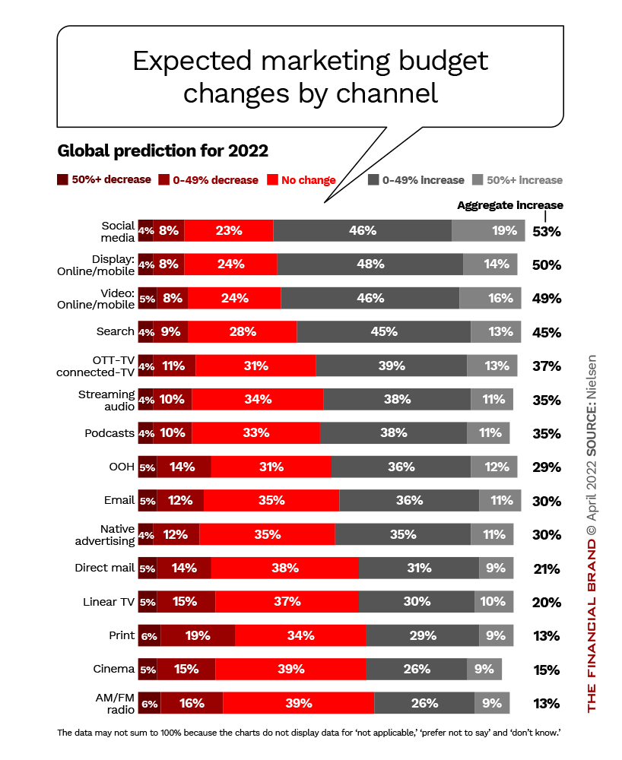

## The Data Set

The data set used in this analysis is from a Portuguese bank. The data set contains 41,188 observations and 21 variables. The variables include the following:

* + age (numeric)
  + job : type of job (categorical: ‘admin.’,‘blue-collar’,‘entrepreneur’,‘housemaid’,‘management’,‘retired’,‘self-employed’,‘services’,‘student’,‘technician’,‘unemployed’,‘unknown’)
  + marital : marital status (categorical: ‘divorced’,‘married’,‘single’,‘unknown’; note: ‘divorced’ means divorced or widowed)
  + education (categorical: ‘basic.4y’,‘basic.6y’,‘basic.9y’,‘high.school’,‘illiterate’,‘professional.course’,‘university.degree’,‘unknown’)
  + default: has credit in default? (categorical: ‘no’,‘yes’,‘unknown’)
  + housing: has housing loan? (categorical: ‘no’,‘yes’,‘unknown’)
  + loan: has personal loan? (categorical: ‘no’,‘yes’,‘unknown’)
  + contact: contact communication type (categorical: ‘cellular’,‘telephone’)
  + month: last contact month of year (categorical: ‘jan’, ‘feb’, ‘mar’, …, ‘nov’, ‘dec’)
  + day_of_week: last contact day of the week (categorical: ‘mon’,‘tue’,‘wed’,‘thu’,‘fri’)
  + duration: last contact duration, in seconds (numeric). Important note: this attribute highly affects the output target (e.g., if duration=0 then y=‘no’). Yet, the duration is not known before a call is performed. Also, after the end of the call y is obviously known. Thus, this input should only be included for benchmark purposes and should be discarded if the intention is to have a realistic predictive model.
  + campaign: number of contacts performed during this campaign and for this client (numeric, includes last contact)
  + pdays: number of days that passed by after the client was last contacted from a previous campaign (numeric; 999 means client was not previously contacted)
  + previous: number of contacts performed before this campaign and for this client (numeric)
  + poutcome: outcome of the previous marketing campaign (categorical: ‘failure’,‘nonexistent’,‘success’)
  + emp.var.rate: employment variation rate - quarterly indicator (numeric)
  + cons.price.idx: consumer price index - monthly indicator (numeric)
  + cons.conf.idx: consumer confidence index - monthly indicator (numeric)
  + euribor3m: euribor 3 month rate - daily indicator (numeric)
  + nr.employed: number of employees - quarterly indicator (numeric)
  + balance - average yearly balance, in euros (numeric)
  + y - has the client subscribed a term deposit? (binary: ‘yes’,‘no’)

## The SMART Questions

 The SMART questions are as follows:

1.Relationship between subscribing the term deposit and how much the customer is contacted (last contact, Campaign, Pdays, Previous Number of contacts) 2.Since the dataset is imbalanced, will down sampling/up sampling or other techniques improve upon the accuracy of models. 3.Marital status, age, job, and loan to find out the financially stable population?Will that affect the outcome? 4.Effect of dimensionality reduction on accuracy of the model. 5.The optimal cut off value for classification of our imbalance dataset. 6.Modeling to estimate the potential population who would subscribe to termdeposit. 7. How are the likelihood of subscriptions affected by social and economic factors?

As per the comments, 2 and 6 are more of analysis than comments so they would be covered in our analysis.

Throughout the paper we would try to answer the questions

## Importing the libraries

import numpy as np   
import pandas as pd   
import os   
import matplotlib.pyplot as plt  
%matplotlib inline  
import warnings  
  
from scipy.stats import zscore  
import seaborn as sns  
import scipy.stats as stats  
import statsmodels.api as sm  
import statsmodels.formula.api as smf  
import statsmodels.stats.api as sms  
import statsmodels.stats.multicomp as mc  
import statsmodels.stats.outliers_influence as influence  
import statsmodels.stats.diagnostic as diag  
import statsmodels.stats.stattools as stattools  
import statsmodels.stats.anova as anova  
import statsmodels.stats.weightstats as weightstats  
import statsmodels.stats.libqsturng as libqsturng  
import statsmodels.stats.power as power  
import statsmodels.stats.proportion as proportion  
import statsmodels.stats.contingency_tables as contingency_tables  
import statsmodels.stats.multitest as multitest  
import statsmodels.stats.diagnostic as diagnostic  
import statsmodels.stats.correlation_tools as correlation_tools  
from statsmodels.formula.api import ols  
import researchpy as rp  
import scipy.stats as stats  
import seaborn as sns  
# Import label encoder  
from sklearn import preprocessing  
warnings.filterwarnings('ignore')  
sns.set_theme(style="whitegrid")  
  
from sklearn.model_selection import train_test_split  
from imblearn.over_sampling import SMOTE  
from sklearn.ensemble import RandomForestClassifier  
from sklearn.svm import SVC, LinearSVC  
from sklearn.naive_bayes import GaussianNB  
from sklearn.neighbors import KNeighborsClassifier  
from sklearn.preprocessing import scale  
from sklearn.cluster import KMeans  
  
from sklearn.linear_model import LogisticRegression  
from sklearn import metrics  
from sklearn.metrics import accuracy_score  
from sklearn.metrics import confusion_matrix   
from sklearn.metrics import classification_report  
from sklearn.feature_selection import RFE  
from sklearn.tree import DecisionTreeClassifier  
from matplotlib import pyplot  
  
from sklearn.model_selection import GridSearchCV  
  
from sklearn.model_selection import cross_validate  
from sklearn.ensemble import RandomForestClassifier  
from sklearn import metrics  
from sklearn.metrics import precision_recall_curve

## Importing the dataset

inputFile = "Dataset/primary.csv"  
df = pd.read_csv(inputFile)

## Basic Information about the data

print(f"Shape of dataset is : {df.shape}")  
print(f"Columns in dataset \n {df.info()}")

Shape of dataset is : (45211, 23)  
<class 'pandas.core.frame.DataFrame'>  
RangeIndex: 45211 entries, 0 to 45210  
Data columns (total 23 columns):  
 # Column Non-Null Count Dtype   
--- ------ -------------- -----   
 0 age 45211 non-null int64   
 1 job 45211 non-null object   
 2 marital 45211 non-null object   
 3 education 45211 non-null object   
 4 default 45211 non-null object   
 5 balance 45211 non-null int64   
 6 housing 45211 non-null object   
 7 loan 45211 non-null object   
 8 contact 45211 non-null object   
 9 day 45211 non-null int64   
 10 month 45211 non-null object   
 11 duration 45211 non-null int64   
 12 campaign 45211 non-null int64   
 13 pdays 45211 non-null int64   
 14 previous 45211 non-null int64   
 15 poutcome 45211 non-null object   
 16 y 45211 non-null int64   
 17 month_int 45211 non-null int64   
 18 cons.conf.idx 45211 non-null float64  
 19 emp.var.rate 45211 non-null float64  
 20 euribor3m 45211 non-null float64  
 21 nr.employed 45211 non-null float64  
 22 cons.price.idx 45211 non-null float64  
dtypes: float64(5), int64(9), object(9)  
memory usage: 7.9+ MB  
Columns in dataset   
 None

Here, we have 45211 variables and 23 columns.

# Exploratory Data Analysis (EDA)

Here we would explore the variables which might be important for subscription of term deposits.

## Analysing the variables

### Job Description

# JOB  
plt.figure(figsize = (8, 5))  
sns.countplot(data=df,y='job',hue='y')  
plt.title("Type of Job Distribution")

Text(0.5, 1.0, 'Type of Job Distribution')

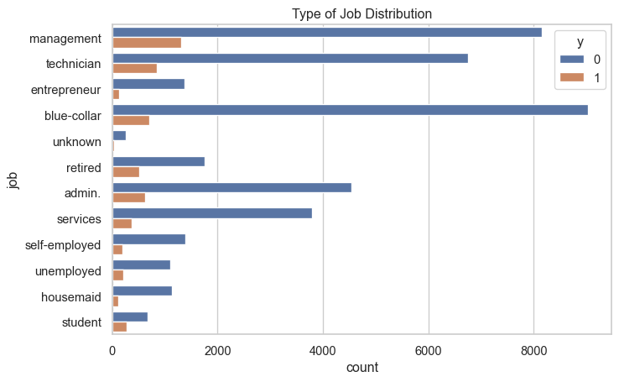

People in management, technical are more likely to subscibe to the term deposit  
So we will explore them later.

### Marital

# MARITAL  
plt.figure(figsize = (8, 5))  
sns.countplot(data=df,y='marital',hue='y')  
plt.title("Type of marital Distribution")

Text(0.5, 1.0, 'Type of marital Distribution')

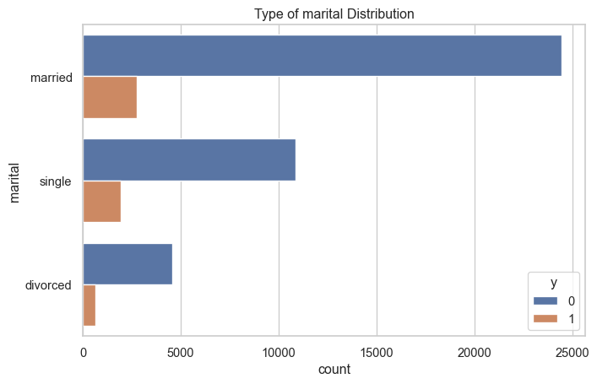

Married and Single are more likely to subscribe for term deposits rather than divorced. But this might also be because of less number of people being divorced in total.

# EDUCATION   
plt.figure(figsize = (8, 5))  
sns.countplot(data=df,y='education',hue='y')  
plt.title("Type of education Distribution")

Text(0.5, 1.0, 'Type of education Distribution')

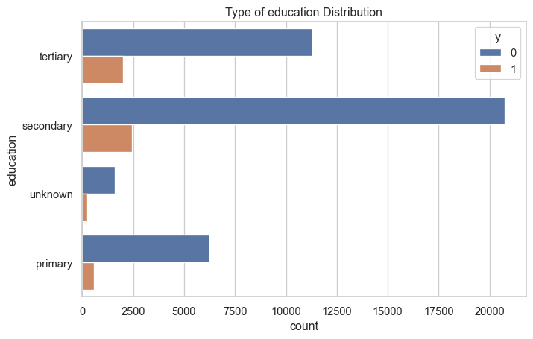

There are unknown values in education that we need to get rid of.

### Loan

# Loan  
sns.countplot(data=df,y='loan',hue='y')  
plt.title("Type of loan Distribution")

Text(0.5, 1.0, 'Type of loan Distribution')

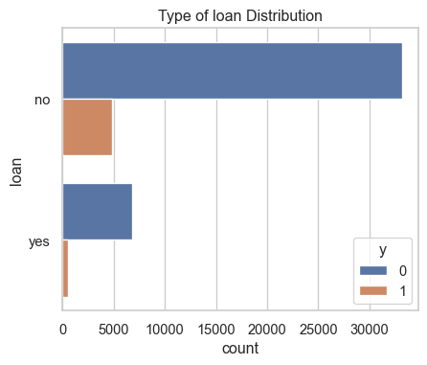

People with personal loans are less likely to subscribe to term deposit but the difference here is not huge.

# Housing Loan  
sns.countplot(data=df,y='housing',hue='y')  
plt.title("Type of housing Distribution")

Text(0.5, 1.0, 'Type of housing Distribution')

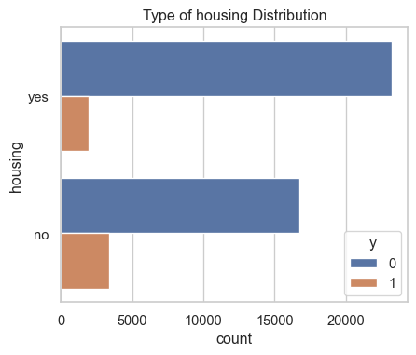

People with housing loans are less likely to subscribe to term deposit but the difference here is not huge.

# DEFAULT  
sns.countplot(data=df,y='default',hue='y')  
plt.title("Type of default Distribution")

Text(0.5, 1.0, 'Type of default Distribution')

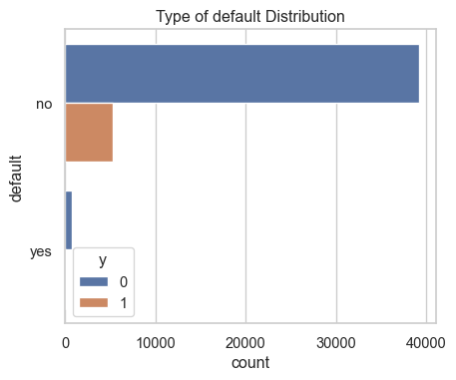

So people who have not paid back there loans and have credits, have not subcribed to the term deposit.

* people who have loans are subscribing to term deposit less.

### Contact

# CONTACT  
sns.countplot(data=df,y='contact',hue='y')  
plt.title("Type of Contact Distribution")

Text(0.5, 1.0, 'Type of Contact Distribution')

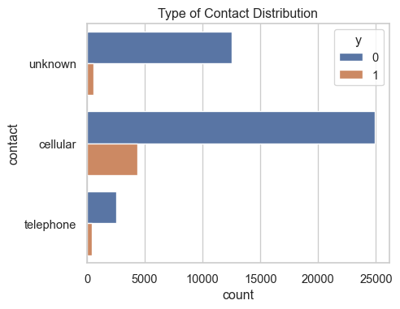

* since the type of communication(cellular and telephone) is not really a good indicator of subcription, we drop this variable.

#### Month

# MONTH  
sns.countplot(x ='month',hue='y', data = df)  
plt.title("Type of Months Distribution")

Text(0.5, 1.0, 'Type of Months Distribution')

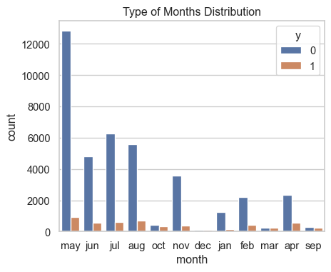

Here,we see that most number of term deposit subscription is in the month of may while the least in the month of december.

def pieChart(x_var,title):  
 yesNo = df.groupby(x_var).size()  
 yesNo.plot(kind='pie', title=title, figsize=[8,8],  
 autopct=lambda p: '{:.2f}%({:.0f})'.format(p,(p/100)*yesNo.sum()))  
 plt.show()

### Term Deposit

Distribution of y(target) variable

pieChart('y','Percentage of yes and no target(term deposit)in dataset')

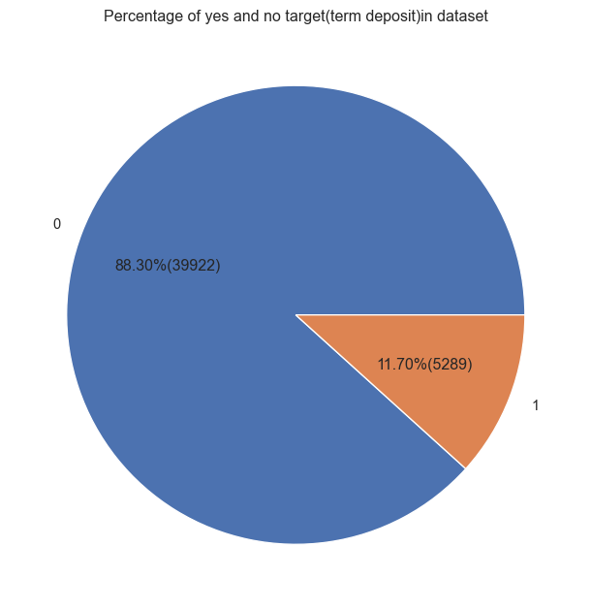

only 11.7% of enteries are for y=1, so our dataset is unbalanced.

# POUTCOME  
pieChart('poutcome','Distribution of poutcome in dataset')  
df.poutcome.value_counts()  
df.groupby('poutcome').size()

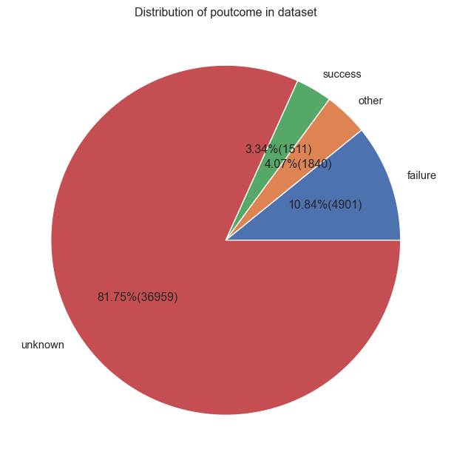

poutcome  
failure 4901  
other 1840  
success 1511  
unknown 36959  
dtype: int64

There are *36959 unknown* values and 1840 values with other category. Since, 82% of entries are unknown, 4.07% other, we will directly drop this column.

## Age, duration and balance

# plotting violen plot for duration and balance   
  
f, axes = plt.subplots(1, 2,sharex=True)  
axes[0].set_title('For duration')  
sns.violinplot( x='y',y='duration', split=True, inner="quart", ax=axes[0], data=df)  
axes[1].set_title('For balance')  
sns.violinplot( x='y',y='balance', split=True, inner="quart", ax=axes[1], data=df)  
sns.despine(left=True)  
plt.show()

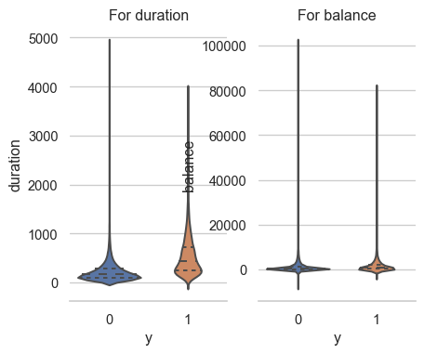

* There are outliers in duration and balance so we need to get rid of them.
* people who have a high balance, are more likely to subscribe to term deposit.

sns.violinplot( x='y',y='age', split=True, inner="quart", data=df)  
plt.title('Age distribution for each response variable')  
plt.show()

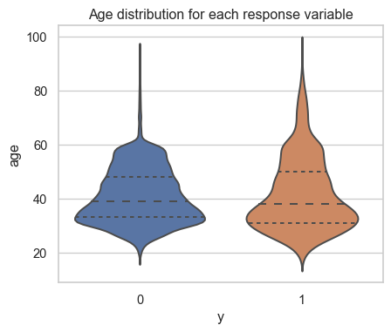

* No outliers
* People who are old are more likely to subscribe to term deposit.

# Summary

## Data Cleaning

* Contact is not useful so we drop it.
* In poutcome, we have a lot of missing values so we drop it.
* Day is not giving any relevant infomation so we drop it.
* Removing the unknowns
* Remove the outliers from balance and duration.

## Data Visualization

# Data Cleaning

## Dropping the column

clean_data = df.drop(['contact','poutcome','day'],axis=1)

As most of the values of poutcome is unknown making the column unimportant in subsequent analysis. More over the day of the week has no significant relation to the subcription of term deposit neither cantact type. ## Removing unknown from job and education

for i in clean_data.columns:  
 if clean_data[i].dtype == np.int64:  
 pass  
 else:  
 # printing names and count using loop.  
 for idx, name in enumerate(clean_data[i].value_counts().index.tolist()):  
 if name == 'unknown' or name == 'other':  
 print(f"for {i}")  
 print(f"{name} : {clean_data[i].value_counts()[idx]}")  
 if clean_data[i].value_counts()[idx] < 15000:  
 print(f"dropping rows with value as {name} in {i}")  
 clean_data = clean_data[clean_data[i] != name]

for job  
unknown : 288  
dropping rows with value as unknown in job  
for education  
unknown : 1730  
dropping rows with value as unknown in education

## Dropping the rows

### Dropping the rows where values are 3SD away

*Balance - Outliers*

standard_deviation = clean_data[['balance']].std()  
mean = clean_data[['balance']].mean()  
clean_data['balance_outliers'] = clean_data['balance']  
clean_data['balance_outliers']= zscore(clean_data['balance_outliers'])  
print(f"removing entries before {mean - 3*standard_deviation } and after {mean + 3*standard_deviation }")  
three_SD = (clean_data['balance_outliers']>3) | (clean_data['balance_outliers']<-3 )  
clean_data = clean_data.drop(clean_data[three_SD].index, axis = 0, inplace = False)  
clean_data = clean_data.drop('balance_outliers', axis=1)

removing entries before balance -7772.283533  
dtype: float64 and after balance 10480.338218  
dtype: float64

*Duration - Outliers*

### Dropping rows where the duration of calls is less than 5sec since that is irrelevant

less_5 = (clean_data['duration']<5)  
clean_data = clean_data.drop(clean_data[less_5].index, axis = 0, inplace = False)

Changing unit of duration from seconds to minutes to make more sense

clean_data['duration'] = clean_data['duration'].apply(lambda n:n/60).round(2)

# Data Visualization

### Contact versus Subscription month wise

### Number of calls versus Duration and affect on subscription

import seaborn as sns  
dur_cam = sns.lmplot(x='duration', y='campaign',data = clean_data,  
 hue = 'y',  
 fit_reg = False,  
 scatter_kws={'alpha':0.6}, height =7)  
  
plt.axis([0,65,0,65])  
plt.ylabel('Number of Calls')  
plt.xlabel('Duration of Calls (Minutes)')  
plt.title('The Relationship between the Number and Duration of Calls (with y)')  
  
# Annotation  
plt.axhline(y=5, linewidth=2, color="k", linestyle='--')  
plt.annotate('Higher subscription rate when number of calls <5 ',xytext = (35,13),  
 arrowprops=dict(color = 'k', width=1),xy=(30,6))  
plt.show()

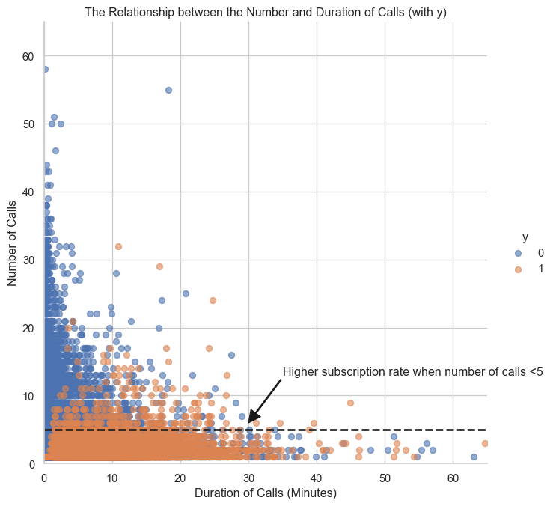

Checking between pdays and previous as well

* + pdays: number of days that passed by after the client was last contacted from a previous campaign (numeric; 999 means client was not previously contacted)
  + previous: number of contacts performed before this campaign and for this client (numeric)

import seaborn as sns  
dur_cam = sns.lmplot(x='pdays', y='previous',data = clean_data,  
 hue = 'y',  
 fit_reg = False,  
 scatter_kws={'alpha':0.6}, height =7)  
  
# plt.axis([0,65,0,65])  
plt.ylabel('pdays')  
plt.xlabel('previous')  
plt.title('The Relationship between number of contacts and last contactbefore this campaign (with y)')  
  
plt.show()

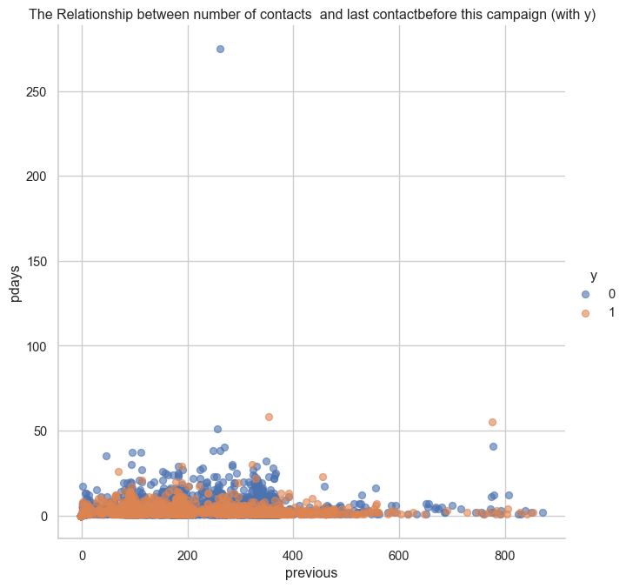

### Smart Question

Based on last contact info only number of contacts performed during this campaign is contributing a lot towards subscription rates.

### Month wise subscription

#converting y values   
# bankdata['y'] = bankdata['y'].apply(lambda x: 'no' if x == 'yes' else 1)  
# bankdata['y'] = bankdata['y'].astype('category')  
  
#value count for each month  
month = clean_data['month'].value_counts().rename_axis('month').reset_index(name='counts')  
#for sequencing the month  
m1_list=['jan','feb','mar','apr','may','jun','jul','aug','sep','nov','dec']  
m1=pd.DataFrame(m1_list,columns=['month'])  
#now the dataset is sequeced  
month = m1.merge(month)  
#month - counts  
#% of people contacted in that month   
month['Contact Rate'] = month['counts']*100/month['counts'].sum()  
#percentage of people contacted in that month   
# y response   
month_y = pd.crosstab(clean_data['y'],clean_data['month']).apply(lambda x: x/x.sum() * 100)  
#% of 0 and 1 for each month   
month_y = month_y.transpose()  
month_y.rename(columns = {'y':'month',0:'no', 1:'yes'}, inplace = True)  
  
# month_y  
# y | no% | yes%

#month = month.merge(month_y)  
month['yes'] = " "  
month['no'] = " "  
#to make it in sequence   
def addingCrossTab():   
 for i, val in enumerate(m1_list):  
 #print (i, ",",val)  
 month['yes'].iloc[i]=month_y.loc[val].loc['yes']  
 #print(month_y.loc[val].loc['yes'])  
 month['no'].iloc[i]=month_y.loc[val].loc['no']  
   
addingCrossTab()   
#print(month)   
#print(month_y)  
# month['Subscription Rate'] = month_y['yes']  
# month['% NotSubscription'] = month_y['no']  
month.rename(columns = {'yes':'Subscription Rate','no':'NotSubscribed Rate'}, inplace = True)  
#month.drop('month_int',axis = 1,inplace = True)  
print(month)

month counts Contact Rate Subscription Rate NotSubscribed Rate  
0 jan 1310 3.134046 10.0 90.0  
1 feb 2492 5.961865 16.332263 83.667737  
2 mar 439 1.050264 53.758542 46.241458  
3 apr 2772 6.631738 19.083694 80.916306  
4 may 13050 31.220843 6.697318 93.302682  
5 jun 4874 11.660566 10.56627 89.43373  
6 jul 6550 15.670231 8.793893 91.206107  
7 aug 5924 14.172588 10.820392 89.179608  
8 sep 514 1.229694 47.66537 52.33463  
9 nov 3679 8.801646 10.192987 89.807013  
10 dec 195 0.466518 45.641026 54.358974

plot_month = month[['month','Subscription Rate','Contact Rate']].plot(x='month',kind ='line',  
 figsize = (10,6),  
 marker = 'o')  
  
plt.title('Subscription vs. Contact Rate by Month')  
plt.ylabel('Subscription and Contact Rate')  
plt.xlabel('Month')

Text(0.5, 0, 'Month')

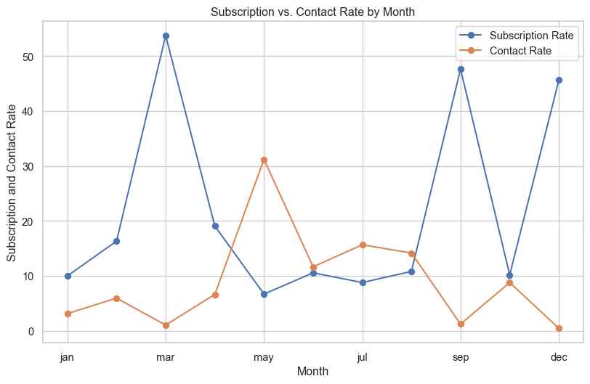

Maximum percentage of people have subscribed in the month of March but bank is contacting people more in the month of May. So it’s better to contact customer’s based on the subcription rate plot.

### Social and economic Factors in month

month_social_economic = clean_data[['month','cons.conf.idx','emp.var.rate','euribor3m','nr.employed']].groupby(['month']).count().reset_index()  
month_list= ['jan','feb','mar','apr','may','jun','jul','aug','sep','oct','nov','dec']  
month_pd = pd.DataFrame(month_list,columns=['month'])  
month_pd = month_pd.merge(month_social_economic,on='month')  
print(month_pd)

month cons.conf.idx emp.var.rate euribor3m nr.employed  
0 jan 1310 1310 1310 1310  
1 feb 2492 2492 2492 2492  
2 mar 439 439 439 439  
3 apr 2772 2772 2772 2772  
4 may 13050 13050 13050 13050  
5 jun 4874 4874 4874 4874  
6 jul 6550 6550 6550 6550  
7 aug 5924 5924 5924 5924  
8 sep 514 514 514 514  
9 oct 661 661 661 661  
10 nov 3679 3679 3679 3679  
11 dec 195 195 195 195

Based on the above table we can see that there is no distinguishable difference in the month of march or may from rest of all the month, so social and economic factor **do not have major influence** on the outcome.

# Checking the Financially stable population

data_vis = clean_data.copy()

## Job

y_job = pd.crosstab(data_vis['y'],data_vis['job']).apply(lambda x: x/x.sum() * 100)  
y_job = y_job.transpose()  
  
y_job.rename(columns = {'y':'job',0:'no', 1:'yes'}, inplace = True)  
jobs_sub = y_job['yes'].sort_values(ascending = True).plot(kind ='barh')  
   
plt.title('Subscription Rate by Job')  
plt.xlabel('Subscription Rate')  
plt.ylabel('Job Category')  
# Label each bar  
for patch_i, label in zip(jobs_sub.patches,  
 y_job['yes'].sort_values(ascending = True).round(1).astype(str)):  
 jobs_sub.text(patch_i.get_width()+1.5,   
 patch_i.get_y()+ patch_i.get_height()-0.5,   
 label+'%',   
 ha = 'center',   
 va='bottom')

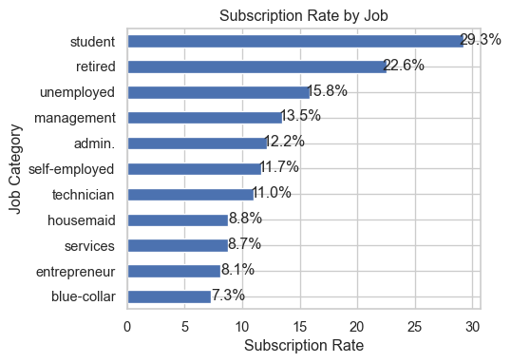

job_contact= data_vis['job'].value_counts().rename_axis('job').reset_index(name='counts')   
job_contact['Contact Rate']= job_contact['counts']*100/job_contact['counts'].sum()   
job_contact['Contact Rate'] = job_contact['Contact Rate'].round(2)  
job_contact=job_contact.drop(['counts'],axis=1)  
  
# job_contact['Contact Rate']= job_contact['Contact Rate'].sort_values(ascending = False)  
job_contact_plot = job_contact.plot(x='job',kind ='barh')   
#.plot(kind ='barh')   
plt.title('Contact Rate by Job')  
plt.xlabel('Contact Rate')  
plt.ylabel('Job Category')  
# Label each bar  
for patch_i, label in zip(job_contact_plot.patches,  
 job_contact['Contact Rate'].astype(str)):  
 job_contact_plot.text(patch_i.get_width()+1.5,   
 patch_i.get_y()+ patch_i.get_height()-0.5,   
 label+'%',   
 ha = 'center',   
 va='bottom')

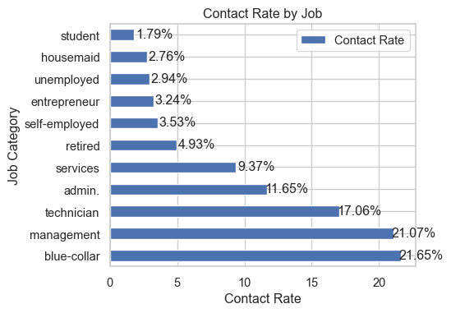

People in blue color and managemnet jobs are contacted more, which should not be the case.

## Balance

#max = 10399  
#min = -6847  
def balance_group(bal):  
 balGroup = 'Negative' if bal < 0 else 'low balance' if bal < 1000 else 'moderate balance' if bal < 2500 else 'high balance'  
 return balGroup  
data_vis['balGroup'] = data_vis['balance'].apply(balance_group)

checking the subscription based on y value

y_balance = pd.crosstab(data_vis['y'],data_vis['balGroup']).apply(lambda x: x/x.sum() * 100)  
y_balance = y_balance.transpose()

Checking the subscriptions in each balance groups

bal = pd.DataFrame(data_vis['balGroup'].value_counts().rename_axis('balGroup').reset_index(name='counts'))  
bal_y = bal.merge(y_balance,on='balGroup')  
  
bal_y['% Contacted'] = bal_y['counts']*100/bal_y['counts'].sum()  
bal_y['% Subscription'] = bal_y[1]  
bal_y.rename(columns = {'y':'month',0:'no', 1:'yes'}, inplace = True)  
  
bal_y = bal_y.drop(['counts','no','yes'],axis=1)  
print(bal_y)  
  
bal_list = ['Negative','low balance', 'moderate balance','high balance']  
balanceGroupInfo =pd.DataFrame(bal_list,columns=['balanceGroup'])  
balanceGroupInfo['Contact Rate'] = " "  
balanceGroupInfo['Subscription Rate'] = " "  
bal_y = bal_y.set_index(['balGroup'])  
  
  
for i,val in enumerate(bal_list):  
 balanceGroupInfo['Contact Rate'].iloc[i]=bal_y.loc[val].loc['% Contacted']  
 balanceGroupInfo['Subscription Rate'].iloc[i]=bal_y.loc[val].loc['% Subscription']  
print(balanceGroupInfo)  
#bal['bal'] = [1,2,0,3]  
#bal = bal.sort_values('bal',ascending = True)

balGroup % Contacted % Subscription  
0 low balance 60.339143 10.503513  
1 moderate balance 17.399906 14.036275  
2 high balance 13.709374 16.715341  
3 Negative 8.551578 5.700909  
 balanceGroup Contact Rate Subscription Rate  
0 Negative 8.551578 5.700909  
1 low balance 60.339143 10.503513  
2 moderate balance 17.399906 14.036275  
3 high balance 13.709374 16.715341

balanceGroupInfo.plot(x='balanceGroup', kind='bar', stacked=False,  
 title='Balance Group Contact Rates and Subscription')  
plt.show()

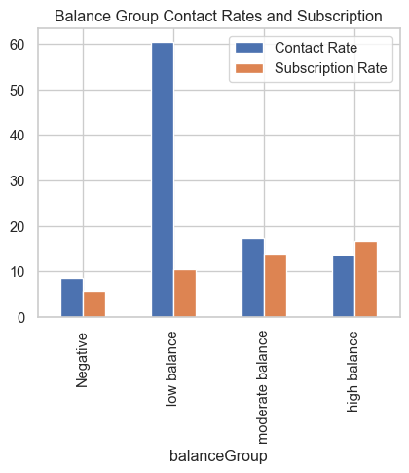

People with moderate to high balance, are contacted less but they have high subscription rates so bank should target them more.

Balance Group versus Job

# add the values for 1   
job_balance = pd.DataFrame(data_vis.groupby(['job','balGroup'])['y'].sum())  
# total number of values   
job_balance_count = pd.DataFrame(data_vis.groupby(['job','balGroup'])['y'].count())  
  
job_balance['y'] = (job_balance['y']/job_balance_count['y'])*100  
job_balance = job_balance.unstack()  
job_balance = job_balance.plot(kind='bar',figsize = (10,6))  
plt.title('Subscription Rates for each balance group in job category')

Text(0.5, 1.0, 'Subscription Rates for each balance group in job category')

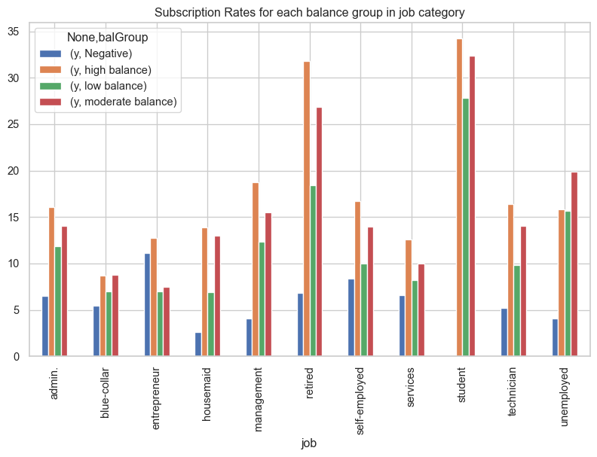

Student and Retired are more likely to subscribe and usually have moderate to high balance.

job_balance_count1 = job_balance_count.unstack()  
job_balance_count1 = job_balance_count1.plot(kind='bar',figsize = (10,6))  
plt.title('Contact for each balance group in job category')

Text(0.5, 1.0, 'Contact for each balance group in job category')

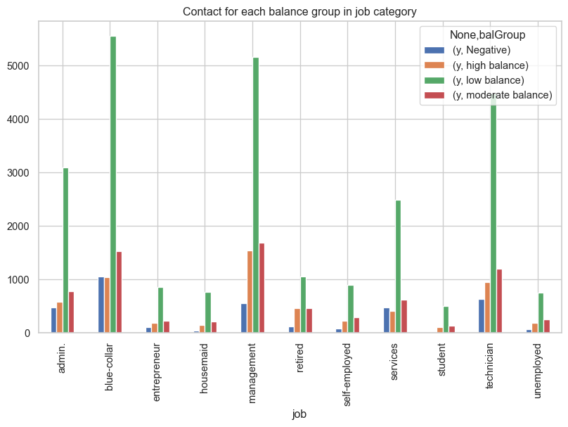

## Loan

covered loan in initial EDA

data_encode = data_vis.copy()

# Getting Data Ready for Modelling

## Encoding

One Hot Encoding

data_encode = pd.get_dummies(data_encode, columns = ['housing'])  
data_encode = pd.get_dummies(data_encode, columns = ['loan'])  
data_encode = pd.get_dummies(data_encode, columns = ['default'])  
data_encode = pd.get_dummies(data_encode, columns = ['job'])  
data_encode = pd.get_dummies(data_encode, columns = ['education'])  
data_encode = pd.get_dummies(data_encode, columns = ['marital'])

Sin - Cos encoding

import math  
from math import pi  
def sin_transformation(x):  
 x=x-1  
 sin_x = math.sin((2*pi*x)/11)  
 return sin_x  
def cos_transformation(x):  
 x=x-1  
 cos_x = math.cos((2*pi*x)/11)  
 return cos_x  
data_encode['sin_month'] = data_encode['month_int'].apply(sin_transformation)   
data_encode['cos_month'] = data_encode['month_int'].apply(cos_transformation)

sns.scatterplot(data=data_encode,x='sin_month',y='cos_month')

<AxesSubplot: xlabel='sin_month', ylabel='cos_month'>

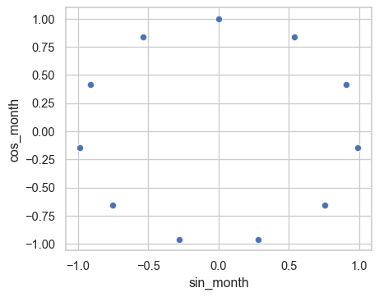

Label Encoding

data_encode= data_encode.drop(['month'],axis=1)  
#data_encode= data_encode.drop(['month_int'],axis=1)  
data_encode = data_encode.drop(['balGroup'],axis=1)  
data_encode = data_encode.drop(['pdays'],axis=1)

Checkpoint

#data_encode.to_csv('Dataset/final_encoded.csv',index=False)  
#data_encode = pd.read_csv('Dataset/final_encoded.csv')

data_model = data_encode.copy()

### Dropping the unecessary varibles for modelling

data_model=data_model.drop(['cons.conf.idx', 'emp.var.rate', 'euribor3m', 'nr.employed',  
 'cons.price.idx'],axis=1)

# Splitting our Dataset

#dropping y to extract x variables   
x = data_model.drop(['y'],axis=1)  
#y variables  
y = data_model['y']  
#splitting the dataset   
x_train,x_test,y_train,y_test = train_test_split(x,y,test_size=0.2)

# Balancing Our Dataset

sm = SMOTE(random_state=42)  
train_sx, train_sy = sm.fit_resample(x_train, y_train)  
test_sx, test_sy = sm.fit_resample(x_test, y_test)  
#printing x and y values   
np.bincount(train_sy)

array([30046, 30046], dtype=int64)

train_sx['sin_month'] = train_sx['month_int'].apply(sin_transformation)   
train_sx['cos_month'] = train_sx['month_int'].apply(cos_transformation)   
  
sns.scatterplot(data=train_sx,x='sin_month',y='cos_month')

<AxesSubplot: xlabel='sin_month', ylabel='cos_month'>



train_sx= train_sx.drop(['month_int'],axis=1)  
test_sx=test_sx.drop(['month_int'],axis=1)

x_train= x_train.drop(['month_int'],axis=1)  
x_test=x_test.drop(['month_int'],axis=1)

Checkpoint 2

train_balanced = pd.concat([train_sx, train_sy], axis=1)  
train_unbalanced = pd.concat([x_train, y_train], axis=1)  
  
test_unbalanced = pd.concat([x_test, y_test], axis=1)  
test_balanced = pd.concat([test_sx, test_sy], axis=1)  
  
# train_balanced.to_csv('Dataset/train_balanced.csv',index=False)  
# train_unbalanced.to_csv('Dataset/train_unbalanced.csv',index=False)  
# test_unbalanced.to_csv('Dataset/test_unbalanced.csv',index=False)  
# test_balanced.to_csv('Dataset/test_balanced.csv',index=False)  
# print("Before Smote")  
# print(f"for training : {np.bincount(y_train)}")  
# print(f"for testing : {np.bincount(y_test)}")  
# print("After smote")  
# print(f"for training : {np.bincount(y_res)}")  
# print(f"for testing : {np.bincount(test_sy)}")

balanced_train= pd.read_csv('Dataset/train_balanced.csv')  
balanced_test= pd.read_csv('Dataset/test.csv')  
unbalanced_train= pd.read_csv('Dataset/train_unbalanced.csv')  
unbalanced_test= pd.read_csv('Dataset/test.csv')

from sklearn.preprocessing import StandardScaler  
# define standard scaler  
scaler = StandardScaler()  
# transform data  
balanced_train[['age','balance','duration']]= scaler.fit_transform(balanced_train[['age','balance','duration']])  
  
balanced_test[['age','balance','duration']]= scaler.fit_transform(balanced_test[['age','balance','duration']])  
  
unbalanced_train[['age','balance','duration']]= scaler.fit_transform(unbalanced_train[['age','balance','duration']])  
  
unbalanced_test[['age','balance','duration']]= scaler.fit_transform(unbalanced_test[['age','balance','duration']])

x_train = unbalanced_train.drop(['y'],axis=1)  
x_test = unbalanced_test.drop(['y'],axis=1)  
y_train = unbalanced_train['y']  
y_test = unbalanced_test['y']

bx_train = balanced_train.drop(['y'],axis=1)  
bx_test = balanced_test.drop(['y'],axis=1)  
by_train = balanced_train['y']  
by_test = balanced_test['y']

# Logistic Regression

Performing Logistic Regression on both balanced and unbalanced dataset. RFE is used in selecting the most important features ## Unbalanced Dataset

rfe_model = RFE(LogisticRegression(solver='lbfgs', max_iter=1000), step= 25)  
rfe_model = rfe_model.fit(x_train,y_train)  
  
# feature selection  
#print(rfe_model.support_)  
#print(rfe_model.ranking_)  
  
selected_columns = x_train.columns[rfe_model.support_]  
list_column= selected_columns.tolist()  
list_column.append('age')  
list_column.append('balance')  
#list_column.append('sin_month')  
print(f"Columns selected by RE {list_column}")  
  
  
X_train_final = x_train[list_column]  
X_test_final = x_test[list_column]  
  
#X_train_final['balance','age'] = x_train['balance','age']  
#X_test_final['balance','age'] = x_test['balance','age']

Columns selected by RE ['duration', 'euribor3m', 'cons.price.idx', 'job_blue-collar', 'job_retired', 'job_student', 'education_primary', 'education_tertiary', 'marital_single', 'housing_no', 'housing_yes', 'loan_no', 'loan_yes', 'poutcome_failure', 'poutcome_success', 'month_apr', 'month_aug', 'month_feb', 'month_jan', 'month_jul', 'month_jun', 'month_mar', 'month_nov', 'month_oct', 'age', 'balance']

As we can see from RFE, the most relevant features are :

* Duration
* Housing
* Loan
* Job
* Education
* cos_month

From other features selection techniques and EDA, we can see that ‘age’ and ‘balance’ also contrubuted to the subscrption, so we added up these variables as well.

Applying model with selected features

lr = LogisticRegression(random_state=123)  
lr.fit(X_train_final, y_train)  
y_pred = lr.predict(X_test_final)  
print(f"Accuracy for training set {accuracy_score(y_train, lr.predict(X_train_final))}")  
print(f"Accuracy for testing set {accuracy_score(y_test, y_pred)}")  
print(f"Confusion matrix \n{confusion_matrix(y_test, y_pred)}")  
print(f"{classification_report(y_test, y_pred)}")

Accuracy for training set 0.8717311715481172  
Accuracy for testing set 0.8713389121338913  
Confusion matrix   
[[4759 148]  
 [ 590 239]]  
 precision recall f1-score support  
  
 0 0.89 0.97 0.93 4907  
 1 0.62 0.29 0.39 829  
  
 accuracy 0.87 5736  
 macro avg 0.75 0.63 0.66 5736  
weighted avg 0.85 0.87 0.85 5736

Here, the accuracy is 89% but the precision(0.59) and recall rate value(0.20) is low. And we also check on the balanced dataset since the low recall rate might be caused because of the less number of y = 1 value.

# Balanced Dataset

rfe_model = RFE(LogisticRegression(solver='lbfgs', max_iter=1000), step= 25)  
rfe_model = rfe_model.fit(bx_train,by_train)  
  
# feature selection  
#print(rfe_model.support_)  
#print(rfe_model.ranking_)  
  
selected_columns = bx_train.columns[rfe_model.support_]  
print(f"Columns selected by RE {selected_columns.tolist()}")  
  
list_column= selected_columns.tolist()  
list_column.append('age')  
list_column.append('balance')  
#list_column.append('sin_month')  
list_column.append('duration')  
#list_column.append('cos_month')  
  
#balanced dataset   
bX_train_final = bx_train[list_column]  
bX_test_final = bx_test[list_column]  
#unbalanced test dataset  
ubx_test_final = x_test[list_column]  
  
lr_b = LogisticRegression(random_state=123)  
lr_b.fit(bX_train_final, by_train)  
by_pred = lr_b.predict(ubx_test_final)  
print(f"Accuracy for training set {accuracy_score(by_train, lr_b.predict(bX_train_final))}")  
print(f"Accuracy for testing set {accuracy_score(y_test, by_pred)}")  
print(f"Confusion matrix \n{confusion_matrix(y_test, by_pred)}")  
print(f"{classification_report(y_test, by_pred)}")

Columns selected by RE ['duration', 'cons.price.idx', 'job_admin.', 'job_blue-collar', 'job_management', 'job_self-employed', 'job_services', 'job_technician', 'job_unemployed', 'education_primary', 'education_secondary', 'education_tertiary', 'marital_divorced', 'marital_married', 'marital_single', 'housing_no', 'housing_yes', 'loan_yes', 'poutcome_failure', 'month_apr', 'month_aug', 'month_jul', 'month_may', 'month_nov']

Accuracy for training set 0.9064744536702155  
Accuracy for testing set 0.8516387726638772  
Confusion matrix   
[[4440 467]  
 [ 384 445]]  
 precision recall f1-score support  
  
 0 0.92 0.90 0.91 4907  
 1 0.49 0.54 0.51 829  
  
 accuracy 0.85 5736  
 macro avg 0.70 0.72 0.71 5736  
weighted avg 0.86 0.85 0.85 5736

Here, important features are * Housing * Loan * Job * Education * Marital Status

We also added the important features from unbalaced dataset * Duration * Age * Month * Balance

Here even though the precision and recall have improved, and accuracy has dropped down, but the important relationships are lost since the training data now is artificially generated datapoints. We will try to find the optimal cut-off value for original dataset and compare it with the model for balanced data.

### Deciding cut off value for logistic regression - Unbalance

But to have good values for cut-off we would try to find a cutoff where the precision and recall values are decent

# Precision-Recall vs Threshold  
#y_pred=logit.predict(x_test)  
y_pred_probs=lr.predict_proba(X_test_final)   
# probs_y is a 2-D array of probability of being labeled as 0 (first   
# column of array) vs 1 (2nd column in array)  
  
precision, recall, thresholds = precision_recall_curve(y_test, y_pred_probs[:, 1])   
#retrieve probability of being 1(in second column of probs_y)  
pr_auc = metrics.auc(recall, precision)  
  
plt.title("Precision-Recall vs Threshold Chart")  
plt.plot(thresholds, precision[: -1], "b--", label="Precision")  
plt.plot(thresholds, recall[: -1], "r--", label="Recall")  
plt.ylabel("Precision, Recall")  
plt.xlabel("Threshold")  
plt.legend(loc="lower left")  
plt.ylim([0,1])  
  
print("\nBased on plot we would choose 0.25 as cut off ")  
  
  
thres = 0.25  
y_pred = np.where(y_pred_probs[:,1]>thres,1,0)  
print(f"Accuracy for testing set {accuracy_score(y_test, y_pred)}")  
print(f"Confusion matrix \n{confusion_matrix(y_test, y_pred)}")  
print(f"{classification_report(y_test, y_pred)}")

Based on plot we would choose 0.25 as cut off   
Accuracy for testing set 0.8589609483960948  
Confusion matrix   
[[4447 460]  
 [ 349 480]]  
 precision recall f1-score support  
  
 0 0.93 0.91 0.92 4907  
 1 0.51 0.58 0.54 829  
  
 accuracy 0.86 5736  
 macro avg 0.72 0.74 0.73 5736  
weighted avg 0.87 0.86 0.86 5736

|  |
| --- |
| Optimal Cutoff at 0.25 |

Here as after applying feature selection, finding optimized cut-off, we are able to achieve higher accuracy with optimal precision and recall. Resulting from the comparison, we would continue our modellings with unbalance dataset.

### Smart Question 5: The optimal cut off value for classification of our imbalance dataset.

**Answer**: The optimal cut off value for our imbalance dataset is 0.25 as the precision- recall chart indicated.

### SMART Question 2: Since the dataset is imbalanced, will down sampling/up sampling or other techniques improve upon the accuracy of models.

**Answer**: As observed from above there is a slight improvement in accuracy, precision and recall after we apply SMOTE, but that improvement can also be acheived by adjusting the cut off value as well. So, we should always try adjusting cut-off first, before upsampling.

For ROC - AUC curve refer (Figure 1).  
For precision recall curve refer(Figure 2).

# Decision Tree

## Feature Selection

# feature selection  
dtc = DecisionTreeClassifier()  
dtc.fit(x_train, y_train)  
importance = dtc.feature_importances_  
features = []   
imp = []  
for i,v in enumerate(importance):  
 if v >0.01:  
 print(f"Feature {i} variable {x_train.columns[i]} score {v:.2f}")  
 features.append(x_train.columns[i])  
 imp.append(v)  
print(f"Important features from decision treee are : \n{features}")  
pyplot.bar([x for x in range(len(importance))], importance)  
pyplot.show()  
x_train_dt = x_train[features]  
x_test_dt = x_test[features]

Feature 0 variable age score 0.09  
Feature 1 variable balance score 0.10  
Feature 2 variable day score 0.09  
Feature 3 variable duration score 0.28  
Feature 4 variable campaign score 0.03  
Feature 5 variable pdays score 0.07  
Feature 6 variable previous score 0.01  
Feature 7 variable cons.conf.idx score 0.01  
Feature 8 variable emp.var.rate score 0.03  
Feature 9 variable euribor3m score 0.02  
Feature 11 variable cons.price.idx score 0.02  
Feature 24 variable education_secondary score 0.01  
Feature 29 variable housing_no score 0.02  
Feature 30 variable housing_yes score 0.02  
Feature 36 variable poutcome_success score 0.05  
Feature 43 variable month_jun score 0.01  
Important features from decision treee are :   
['age', 'balance', 'day', 'duration', 'campaign', 'pdays', 'previous', 'cons.conf.idx', 'emp.var.rate', 'euribor3m', 'cons.price.idx', 'education_secondary', 'housing_no', 'housing_yes', 'poutcome_success', 'month_jun']

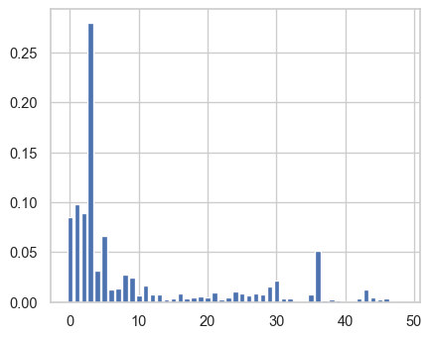

Features selected from this algorithm are

* Age
* Balance
* Duration
* Campaign
* Previous
* Housing
* Job
* Education
* Marital
* Month - Sin,cos

We have all the important features from EDA here

## Hyperparameter tuning

For tuning the hyperparameter’s we will use GridSearch CV.

# Creating a dictionary of parameters to use in GridSearchCV  
  
params = {  
 'criterion': ['gini', 'entropy'],  
 'max_depth': [None, 2, 4, 6, 8, 10],  
 'max_features': [None, 'sqrt', 'log2', 0.2, 0.4, 0.6, 0.8],  
 'splitter': ['best', 'random']  
}  
  
clf = GridSearchCV(  
 estimator=DecisionTreeClassifier(),  
 param_grid=params,  
 cv=5,  
 n_jobs=5,  
 verbose=1,  
)  
  
clf.fit(x_train_dt, y_train)  
print(f"Best parameters from Grid Search CV : \n{clf.best_params_}")

Fitting 5 folds for each of 168 candidates, totalling 840 fits

Best parameters from Grid Search CV :   
{'criterion': 'gini', 'max_depth': 6, 'max_features': None, 'splitter': 'best'}

Training model based on the parameters we got from Grid SearchCV.

dtc = DecisionTreeClassifier(criterion='entropy',max_depth=8,max_features= 0.8,splitter='best')  
dtc.fit(x_train_dt,y_train )  
dtcprediction = dtc.predict(x_test_dt)  
print(accuracy_score(y_test, dtcprediction))  
print(confusion_matrix(y_test, dtcprediction))  
print(classification_report(y_test, dtcprediction))

0.8795327754532776  
[[4631 276]  
 [ 415 414]]  
 precision recall f1-score support  
  
 0 0.92 0.94 0.93 4907  
 1 0.60 0.50 0.55 829  
  
 accuracy 0.88 5736  
 macro avg 0.76 0.72 0.74 5736  
weighted avg 0.87 0.88 0.87 5736

From the decision tree we have better precision, recall, accuracy and thus better f1 score. Hence, decision tree is performing better than logistic regression.

AUC Curve : Figure 1  
Precision Recall Curve : Figure 2

# Random Forest

## Feature Selection

rfc = RandomForestClassifier()  
rfc.fit(x_train, y_train)  
importance_rfc = rfc.feature_importances_  
features_rfc = []   
for i,v in enumerate(importance_rfc):  
 if v >0.01:  
 #print(f"Feature {i} variable {balanced_train.columns[i]} score {v}")  
 features_rfc.append(balanced_train.columns[i])  
print(f"Important features from random forest :\n{features_rfc}")  
pyplot.bar([x for x in range(len(importance_rfc))], importance_rfc)  
pyplot.show()  
#selecting important features  
x_train_rf = x_train[features_rfc]  
x_test_rf = x_test[features_rfc]

Important features from random forest :  
['age', 'balance', 'day', 'duration', 'campaign', 'pdays', 'previous', 'cons.conf.idx', 'emp.var.rate', 'euribor3m', 'nr.employed', 'cons.price.idx', 'job_management', 'job_technician', 'education_secondary', 'education_tertiary', 'marital_married', 'marital_single', 'housing_no', 'housing_yes', 'poutcome_failure', 'poutcome_success']

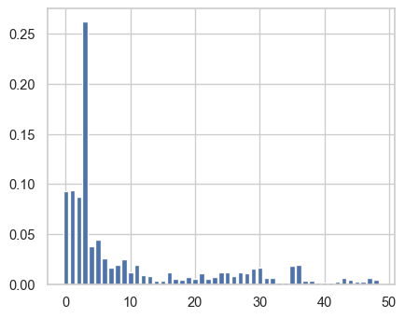

## Hyperparameter Tuning

# Create the parameter grid based on the results of random search   
param_grid = {  
 'bootstrap': [True],  
 'max_depth': [80, 90, 100, 110],  
 'max_features': [2, 3],  
 'n_estimators': [100, 200, 300, 1000]  
}  
# Create a based model  
rf = RandomForestClassifier()  
# Instantiate the grid search model  
grid_search = GridSearchCV(estimator = rf, param_grid =param_grid, cv = 3, n_jobs = -1, verbose = 2)  
grid_search.fit(x_train_rf, y_train)  
grid_search.best_params_

Fitting 3 folds for each of 32 candidates, totalling 96 fits

{'bootstrap': True, 'max_depth': 110, 'max_features': 3, 'n_estimators': 1000}

rfc = RandomForestClassifier(bootstrap=True,max_depth=80,max_features=3,n_estimators=200)  
rfc.fit(x_train_rf, y_train)  
rfcpredictions = rfc.predict(x_test_rf)  
print(f"Training accuracy {accuracy_score(y_train, rfc.predict(x_train_rf))}")  
print(f"Testing set accuracy {accuracy_score(y_test, rfcpredictions )}")  
print(confusion_matrix(y_test, rfcpredictions ))  
print(classification_report(y_test, rfcpredictions ))

Training accuracy 1.0  
Testing set accuracy 0.8877266387726639  
[[4719 188]  
 [ 456 373]]  
 precision recall f1-score support  
  
 0 0.91 0.96 0.94 4907  
 1 0.66 0.45 0.54 829  
  
 accuracy 0.89 5736  
 macro avg 0.79 0.71 0.74 5736  
weighted avg 0.88 0.89 0.88 5736

We are getting best performance from Random Forest, so we would also use cross validation to make our model more credible.

# from sklearn.model_selection import cross_val_score  
# scores = cross_val_score(rfc, x_train_rf, y_train, cv=5)  
# print(scores)  
  
# K-Fold Cross-Validation  
  
def cross_validation(model, _X, _y, _cv=5):  
 '''Function to perform 5 Folds Cross-Validation  
 Parameters  
 ----------  
 model: Python Class, default=None  
 This is the machine learning algorithm to be used for training.  
 _X: array  
 This is the matrix of features.  
 _y: array  
 This is the target variable.  
 _cv: int, default=5  
 Determines the number of folds for cross-validation.  
 Returns  
 -------  
 The function returns a dictionary containing the metrics 'accuracy', 'precision',  
 'recall', 'f1' for both training set and validation set.  
 '''  
 _scoring = ['accuracy', 'precision', 'recall', 'f1']  
 results = cross_validate(estimator=model,  
 X=_X,  
 y=_y,  
 cv=_cv,  
 scoring=_scoring,  
 return_train_score=True)  
   
 return {"Training Accuracy scores": results['train_accuracy'],  
 "Mean Training Accuracy": results['train_accuracy'].mean()*100,  
 "Training Precision scores": results['train_precision'],  
 "Mean Training Precision": results['train_precision'].mean(),  
 "Training Recall scores": results['train_recall'],  
 "Mean Training Recall": results['train_recall'].mean(),  
 "Training F1 scores": results['train_f1'],  
 "Mean Training F1 Score": results['train_f1'].mean(),  
 "Validation Accuracy scores": results['test_accuracy'],  
 "Mean Validation Accuracy": results['test_accuracy'].mean()*100,  
 "Validation Precision scores": results['test_precision'],  
 "Mean Validation Precision": results['test_precision'].mean(),  
 "Validation Recall scores": results['test_recall'],  
 "Mean Validation Recall": results['test_recall'].mean(),  
 "Validation F1 scores": results['test_f1'],  
 "Mean Validation F1 Score": results['test_f1'].mean()  
 }  
cross_validation(rfc, x_train_rf, y_train, _cv=5)

{'Training Accuracy scores': array([1., 1., 1., 1., 1.]),  
 'Mean Training Accuracy': 100.0,  
 'Training Precision scores': array([1., 1., 1., 1., 1.]),  
 'Mean Training Precision': 1.0,  
 'Training Recall scores': array([1., 1., 1., 1., 1.]),  
 'Mean Training Recall': 1.0,  
 'Training F1 scores': array([1., 1., 1., 1., 1.]),  
 'Mean Training F1 Score': 1.0,  
 'Validation Accuracy scores': array([0.88603182, 0.88145565, 0.8893005 , 0.88603182, 0.89210985]),  
 'Mean Validation Accuracy': 88.6985927646624,  
 'Validation Precision scores': array([0.64631579, 0.64619165, 0.67494357, 0.65555556, 0.68351648]),  
 'Mean Validation Precision': 0.6613046082657583,  
 'Validation Recall scores': array([0.46374622, 0.39668175, 0.45098039, 0.44494721, 0.46978852]),  
 'Mean Validation Recall': 0.4452288189270595,  
 'Validation F1 scores': array([0.54001759, 0.49158879, 0.54068716, 0.53009883, 0.5568487 ]),  
 'Mean Validation F1 Score': 0.5318482140004461}

After applying cross validation, we are getting some what real estimates.

AUC Curve : Figure 1  
Precision Recall Curve : Figure 2

# Linear SVC

Finding a linear hyperplane that tries to separate two classes.

svc_linear = LinearSVC(C=1.0, class_weight=None, dual=True, fit_intercept=True,  
 intercept_scaling=1, loss='squared_hinge', max_iter=1000,  
 multi_class='ovr', penalty='l2', random_state=123, tol=0.0001,  
 verbose=0)  
svc_linear.fit(x_train,y_train)  
svc_linear_predictions = svc_linear.predict(x_test)  
print(accuracy_score(y_test, svc_linear_predictions))  
print(confusion_matrix(y_test, svc_linear_predictions))  
print(classification_report(y_test, svc_linear_predictions))

0.8559972105997211  
[[4898 9]  
 [ 817 12]]  
 precision recall f1-score support  
  
 0 0.86 1.00 0.92 4907  
 1 0.57 0.01 0.03 829  
  
 accuracy 0.86 5736  
 macro avg 0.71 0.51 0.48 5736  
weighted avg 0.82 0.86 0.79 5736

# SVC

Finding a complex hyperplane that tries to separate the classes.

# SVM - Support Vector Machines balance check on unbalance test  
svc= SVC(kernel='poly', random_state=123)  
svc.fit(x_train,y_train)  
svcpredictions = svc.predict(x_test)  
print(accuracy_score(y_test, svcpredictions))  
print(confusion_matrix(y_test, svcpredictions))  
print(classification_report(y_test, svcpredictions))

0.8554741980474198  
[[4907 0]  
 [ 829 0]]  
 precision recall f1-score support  
  
 0 0.86 1.00 0.92 4907  
 1 0.00 0.00 0.00 829  
  
 accuracy 0.86 5736  
 macro avg 0.43 0.50 0.46 5736  
weighted avg 0.73 0.86 0.79 5736

# Naive Bayes

Naive Bayes a naive assumption that all the features are independent of each other and thus by reducing the complexity of computing conditional probabilities it evaluates the probability of 0 and 1.

param_grid_nb = {  
 'var_smoothing': np.logspace(0,-9, num=100)  
}  
nbModel_grid = GridSearchCV(estimator=GaussianNB(), param_grid=param_grid_nb, verbose=1, cv=10, n_jobs=-1)  
nbModel_grid.fit(x_train, y_train)  
print(nbModel_grid.best_estimator_)  
  
from sklearn.naive_bayes import GaussianNB  
modelNB = GaussianNB(var_smoothing=0.04328761281083057)  
modelNB.fit(x_train,y_train)  
print(f"Model score is {modelNB.score(x_test,y_test)}")  
def modelProbability(prediction0,prediction1,y):  
 plt.figure(figsize=(15,7))  
 plt.hist(prediction1[y==0], bins=50, label='No/probability 1', alpha=0.7, color='g')  
 plt.hist(prediction0[y==0], bins=50, label='No/probability 0')  
 plt.hist(prediction0[y==1], bins=50, label='Yes/probability 0', alpha=0.7, color='r')  
 plt.hist(prediction1[y==1], bins=50, label='Yes/probability 1', alpha=0.7, color='y')  
 plt.xlabel('Probability of being Positive/Negative Class', fontsize=25)  
 plt.ylabel('Number of records in each bucket', fontsize=25)  
 plt.legend(fontsize=15)  
 plt.tick_params(axis='both', labelsize=25, pad=5)  
 plt.show()   
pred1=modelNB.predict_proba(x_test)[:,0]  
pred2 = modelNB.predict_proba(x_test)[:,1]  
modelProbability(pred1,pred2,y_test)  
  
#modelling  
def modelEvaluation(model,x,y):  
 print('test set evaluation: ')  
 y_pred = model.predict(x)  
 print(accuracy_score(y, y_pred))  
 print(confusion_matrix(y, y_pred))  
 print(classification_report(y, y_pred))  
   
modelEvaluation(modelNB,x_test,y_test)

Fitting 10 folds for each of 100 candidates, totalling 1000 fits

GaussianNB(var_smoothing=0.0657933224657568)  
Model score is 0.8561715481171548

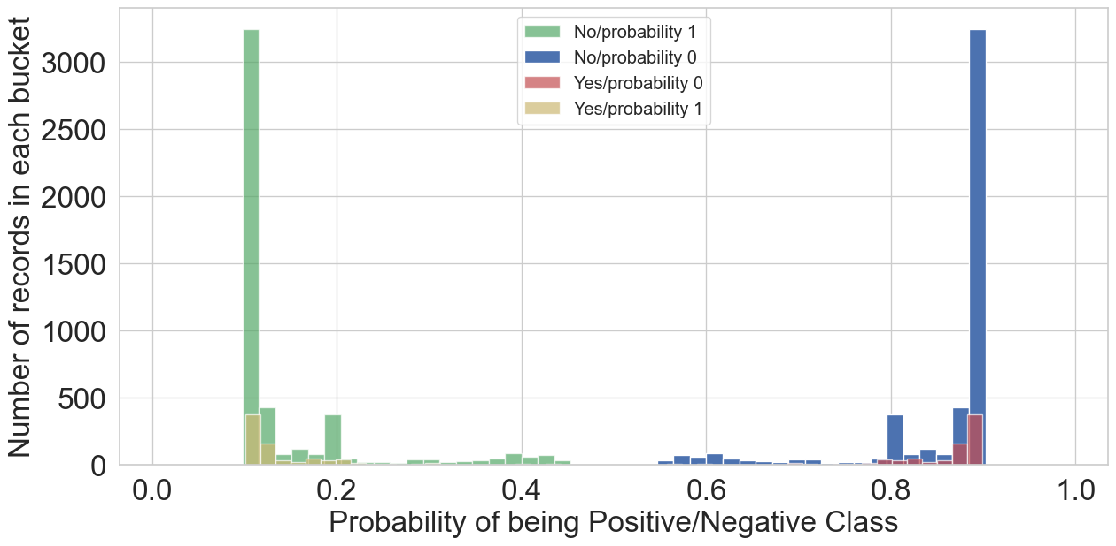

test set evaluation:   
0.8561715481171548  
[[4892 15]  
 [ 810 19]]  
 precision recall f1-score support  
  
 0 0.86 1.00 0.92 4907  
 1 0.56 0.02 0.04 829  
  
 accuracy 0.86 5736  
 macro avg 0.71 0.51 0.48 5736  
weighted avg 0.81 0.86 0.80 5736

## For balanced

For balanced dataset, as we can see there is a slight improvement in performance. The f1 score has improved and also, the yellow bars are now slightly shifted towards right side.

param_grid_nb = {  
 'var_smoothing': np.logspace(0,-9, num=100)  
}  
  
from sklearn.naive_bayes import GaussianNB  
modelNB = GaussianNB(var_smoothing=0.04328761281083057)  
modelNB.fit(bx_train,by_train)  
print(f"Model score is {modelNB.score(x_test,y_test)}")  
def modelProbability(prediction0,prediction1,y):  
 plt.figure(figsize=(15,7))  
 plt.hist(prediction1[y==0], bins=50, label='No/probability 1', alpha=0.7, color='g')  
 plt.hist(prediction0[y==0], bins=50, label='No/probability 0')  
 plt.hist(prediction0[y==1], bins=50, label='Yes/probability 0', alpha=0.7, color='r')  
 plt.hist(prediction1[y==1], bins=50, label='Yes/probability 1', alpha=0.7, color='y')  
 plt.xlabel('Probability of being Positive/Negative Class', fontsize=25)  
 plt.ylabel('Number of records in each bucket', fontsize=25)  
 plt.legend(fontsize=15)  
 plt.tick_params(axis='both', labelsize=25, pad=5)  
 plt.show()   
pred1=modelNB.predict_proba(x_test)[:,0]  
pred2 = modelNB.predict_proba(x_test)[:,1]  
modelProbability(pred1,pred2,y_test)  
  
#modelling  
def modelEvaluation(model,x,y):  
 print('test set evaluation: ')  
 y_pred = model.predict(x)  
 print(accuracy_score(y, y_pred))  
 print(confusion_matrix(y, y_pred))  
 print(classification_report(y, y_pred))  
   
modelEvaluation(modelNB,x_test,y_test)

Model score is 0.693863319386332

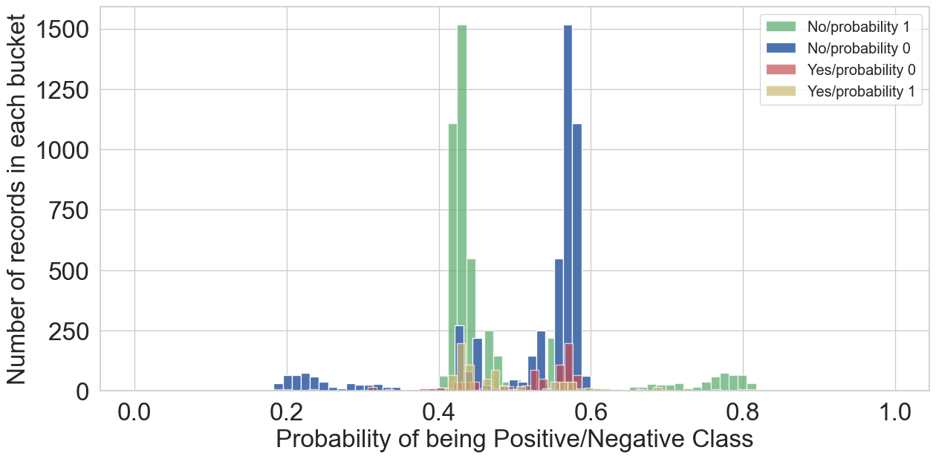

test set evaluation:   
0.693863319386332  
[[3690 1217]  
 [ 539 290]]  
 precision recall f1-score support  
  
 0 0.87 0.75 0.81 4907  
 1 0.19 0.35 0.25 829  
  
 accuracy 0.69 5736  
 macro avg 0.53 0.55 0.53 5736  
weighted avg 0.77 0.69 0.73 5736

As we can see from the graph for the red and yellow bars for yes(1 term deposit) are coming on the opposite sides which is not expected.

AUC Curve : Figure 1  
Precision Recall Curve : Figure 2

# KNN

Using the k - nearest neighbours we try to predict the testing dataset. Now to find the optimal k value we will look into precision and accuracy curve for different k values.

acc = []  
prec = []  
# Will take some time  
from sklearn import metrics  
for i in range(1,40):  
 neigh = KNeighborsClassifier(n_neighbors = i).fit(x_train,y_train)  
 y_pred = neigh.predict(x_test)  
 acc.append(metrics.accuracy_score(y_test, y_pred))  
 prec.append((metrics.average_precision_score(y_test, y_pred)))

plt.figure(figsize=(10,6))  
plt.plot(range(1,40),acc,color = 'blue',linestyle='dashed',   
 marker='o',markerfacecolor='red', markersize=10)  
plt.title('accuracy vs. K Value')  
plt.xlabel('K')  
plt.ylabel('Accuracy')  
print("Maximum accuracy:-",max(acc),"at K =",acc.index(max(acc)))

Maximum accuracy:- 0.8769177126917713 at K = 19

|  |
| --- |
| Accuracy curve for different k values |

#plt.figure(figsize=(10,6))  
plt.plot(range(1,40),prec,color = 'blue',linestyle='dashed',   
 marker='o',markerfacecolor='red', markersize=10)  
plt.title('precision vs. K Value')  
plt.xlabel('K')  
plt.ylabel('Precision')  
print("Maximum Precision:-",max(prec),"at K =",prec.index(max(prec)))

Maximum Precision:- 0.32247407633937064 at K = 8

|  |
| --- |
| Precision curve for different k values |

Based on the above plot, optimal k value is 3, with maximum f1 score of 0.64.

mrroger = 3  
knn = KNeighborsClassifier(n_neighbors=mrroger) # instantiate with n value given  
knn.fit(x_train,y_train)  
y_pred = knn.predict(x_test)  
#y_pred = knn.predict_proba(x_test)  
print(f"Train set accuracy {accuracy_score(y_train, knn.predict(x_train))}")  
print(f"Test set accuracy {accuracy_score(y_test, y_pred)}")  
print(confusion_matrix(y_test, y_pred))  
print(classification_report(y_test, y_pred))

Train set accuracy 0.9197611576011158  
Test set accuracy 0.8657601115760112  
[[4626 281]  
 [ 489 340]]  
 precision recall f1-score support  
  
 0 0.90 0.94 0.92 4907  
 1 0.55 0.41 0.47 829  
  
 accuracy 0.87 5736  
 macro avg 0.73 0.68 0.70 5736  
weighted avg 0.85 0.87 0.86 5736

AUC Curve : Figure 1  
Precision Recall Curve : Figure 2

# ROC -AUC Curve

from sklearn.metrics import roc_auc_score, roc_curve  
  
# Instantiate the classfiers and make a list  
classifiers = [LogisticRegression(random_state=123),  
 DecisionTreeClassifier(criterion='entropy',max_depth=8,max_features= 0.8,splitter='best'),  
 RandomForestClassifier(bootstrap=True,max_depth=80,max_features=3,n_estimators=200),  
 #SVC(kernel='poly', random_state=123),  
 GaussianNB(var_smoothing=0.04328761281083057),  
 KNeighborsClassifier(n_neighbors=mrroger)]  
  
# Define a result table as a DataFrame  
result_table = pd.DataFrame(columns=['classifiers', 'fpr','tpr','auc'])  
X_train = x_train  
X_test = x_test  
# Train the models and record the results  
for cls in classifiers:  
 model = cls.fit(X_train, y_train)  
 yproba = model.predict_proba(X_test)[::,1]  
   
 fpr, tpr, _ = roc_curve(y_test, yproba)  
 auc = roc_auc_score(y_test, yproba)  
   
 result_table = result_table.append({'classifiers':cls.__class__.__name__,  
 'fpr':fpr,   
 'tpr':tpr,   
 'auc':auc}, ignore_index=True)  
  
# Set name of the classifiers as index labels  
result_table.set_index('classifiers', inplace=True)  
  
fig = plt.figure(figsize=(8,6))  
  
for i in result_table.index:  
 plt.plot(result_table.loc[i]['fpr'],   
 result_table.loc[i]['tpr'],   
 label="{}, AUC={:.3f}".format(i, result_table.loc[i]['auc']))  
   
plt.plot([0,1], [0,1], color='orange', linestyle='--')  
  
plt.xticks(np.arange(0.0, 1.1, step=0.1))  
plt.xlabel("Flase Positive Rate", fontsize=15)  
  
plt.yticks(np.arange(0.0, 1.1, step=0.1))  
plt.ylabel("True Positive Rate", fontsize=15)  
  
plt.title('ROC Curve Analysis', fontweight='bold', fontsize=15)  
plt.legend(prop={'size':13}, loc='lower right')  
  
plt.show()

|  |
| --- |
| Figure 1: AUC ROC Curve for all Models |

# Precision Recall Curve

In imbalance problem since we have a high number of Negatives, this makes the False Posiitve Rate as low, resulting in the shift of ROC AUC Curve towards left, which is slightly misleading.

So in imbalance problem we usually make sure to look at precision recall curve as well.

#Logistic Regression  
lr_probs = lr.predict_proba(X_test_final)  
lr_probs = lr_probs[:, 1]  
yhat = lr.predict(X_test_final)  
lr_precision, lr_recall, _ = precision_recall_curve(y_test, lr_probs)  
no_skill = len(y_test[y_test==1]) / len(y_test)  
pyplot.plot([0, 1], [no_skill, no_skill], linestyle='--', label='No Skill')  
pyplot.plot(lr_recall, lr_precision, marker='.', label='Logistic')  
# axis labels  
  
#Decision Tree Classifier  
dtc_probs = dtc.predict_proba(x_test_dt)  
dtc_probs = dtc_probs[:, 1]  
yhat = dtc.predict(x_test_dt)  
dtc_precision, dtc_recall, _ = precision_recall_curve(y_test, dtc_probs)  
no_skill = len(y_test[y_test==1]) / len(y_test)  
pyplot.plot(dtc_recall, dtc_precision, marker='.', label='Decision Tree')  
  
#Random Forest Classifier  
rfc_probs = rfc.predict_proba(x_test_rf)  
rfc_probs = rfc_probs[:, 1]  
yhat = rfc.predict(x_test_rf)  
rfc_precision, rfc_recall, _ = precision_recall_curve(y_test, rfc_probs)  
no_skill = len(y_test[y_test==1]) / len(y_test)  
pyplot.plot(rfc_recall, rfc_precision, marker='.', label='Random Forest')  
  
#Gaussian Model  
nb_probs = modelNB.predict_proba(x_test)  
# keep probabilities for the positive outcome only  
nb_probs = nb_probs[:, 1]  
# predict class values  
yhat = modelNB.predict(x_test)  
nb_precision, nb_recall, _ = precision_recall_curve(y_test, nb_probs)  
no_skill = len(y_test[y_test==1]) / len(y_test)  
pyplot.plot(nb_recall, nb_precision, marker='.', label='Naive Bayes')  
  
#knn  
knn_probs = knn.predict_proba(x_test)  
knn_probs = knn_probs[:, 1]  
yhat = knn.predict(x_test)  
knn_precision, knn_recall, _ = precision_recall_curve(y_test, knn_probs)  
no_skill = len(y_test[y_test==1]) / len(y_test)  
pyplot.plot(knn_recall, knn_precision, marker='.', label='KNN')  
  
  
pyplot.xlabel('Recall')  
pyplot.ylabel('Precision')  
# show the legend  
pyplot.legend()  
# show the plot  
pyplot.show()

|  |
| --- |
| Figure 2: Precision Recall Curve for all Models |

As per the ROC Curve and Precision Recall curve, KNN is performing best. But after combining these results with precision recall curve, we suggest using Random Forest for our problem.

# Summary

Table 1: Summary of Models

| Model | Accuracy | Precision | Recall | AUC |
| --- | --- | --- | --- | --- |
| Logistic(Cutoff=0.25) | 0.88 | 0.51 | 0.58 | 0.872 |
| Logistic (Balanced-Train) | 0.85 | 0.49 | 0.54 |  |
| Decision Tree | 0.91 | 0.66 | 0.47 | 0.923 |
| Random Forest | 0.88 | 0.66 | 0.46 | 0.913 |
| SVC | 0.89 | 0.75 | 0.15 |  |
| Linear SVC | 0.89 | 0.62 | 0.16 |  |
| Gaussian Bayes | 0.88 | 0.50 | 0.25 | 0.841 |
| KNN | 0.92 | 0.78 | 0.54 | 0.965 |
| Naive Bayes | 0.85 | 0.56 | 0.02 |  |
| Naive Bayes (Balanced-Train) | 0.69 | 0.19 | 0.35 |  |

See Table 1.